Name-Vaishnavi Shirke
Roll no – MCA-2504097
Lab 6: Build a Real CI Pipeline Using Jenkins Scripted Pipeline

Project Scenario
ABC Software Pvt. Ltd. develops a simple Calculator application.
Whenever a developer pushes code to GitHub, Jenkins should automatically
- Download the latest code
- Install dependencies
- Run the application
- Execute unit tests
- Check coding standards
- Generate coverage report
- Store reports
- Notify whether build succeeded or failed
Today you are the DevOps Engineer responsible for building this CI pipeline.

Project Structure
Create a folder
StudentManagementSystem

Inside it create
StudentManagementSystem
│
├── app.py
├── calculator.py
├── requirements.txt
├── test_calculator.py
├── Jenkinsfile
├── README.md
├── .gitignore
└── reports

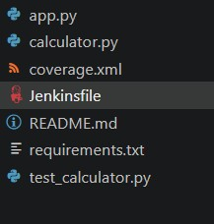

Step 1 Create calculator.py
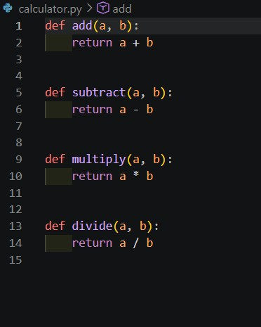

Step 2 Create app.py
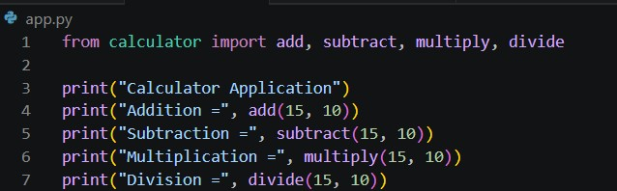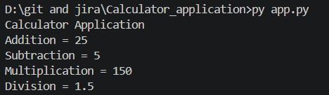

Step 3 Create requirements.txt
pytest coverage flake8
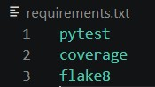

Step 4 Create Unit Test
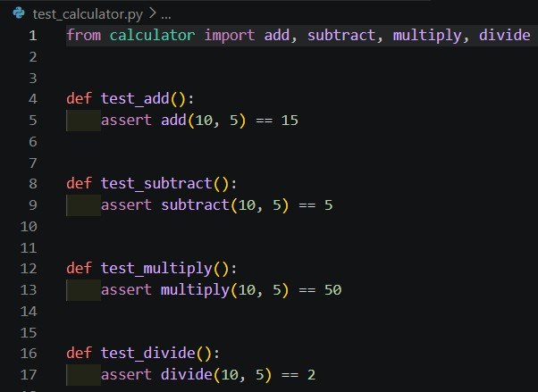

Step 5 Test Locally
Install packages: pip install -r requirements.txt
Run:- pytest
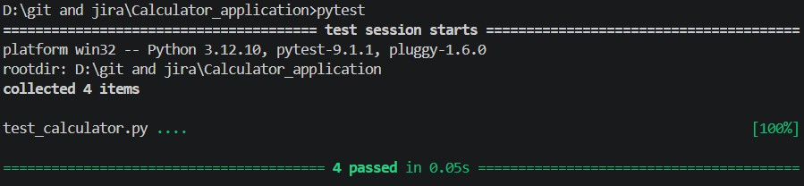

Step 6 Check Code Quality
Run: flake8 .
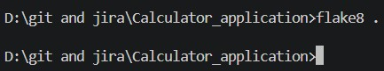

Step 7 Generate Coverage
Run: coverage run -m pytest Now generate report
coverage xml

A file
coverage.xml
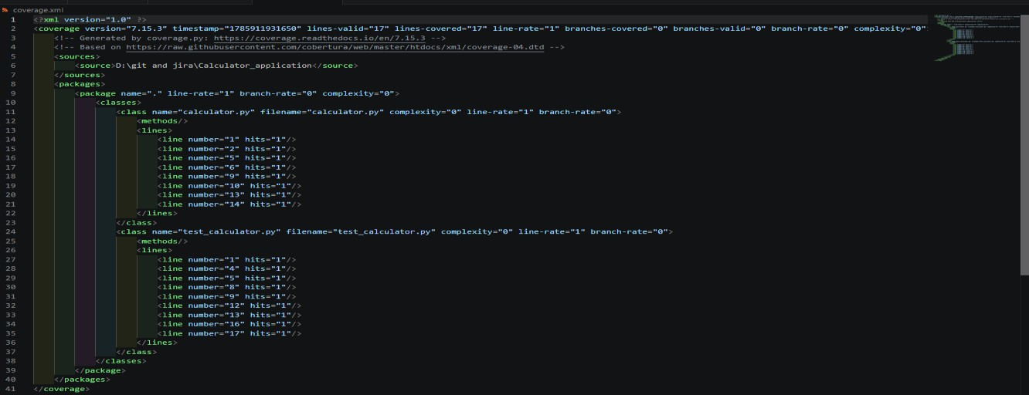

Step 8 Initialize Git
git init git add .
git commit -m "Completed Calculator Project" Repository Name: student-management-system git remote add origin
git branch -M main

git push -u origin main

Step 9 Create Jenkinsfile
Create
Jenkinsfile
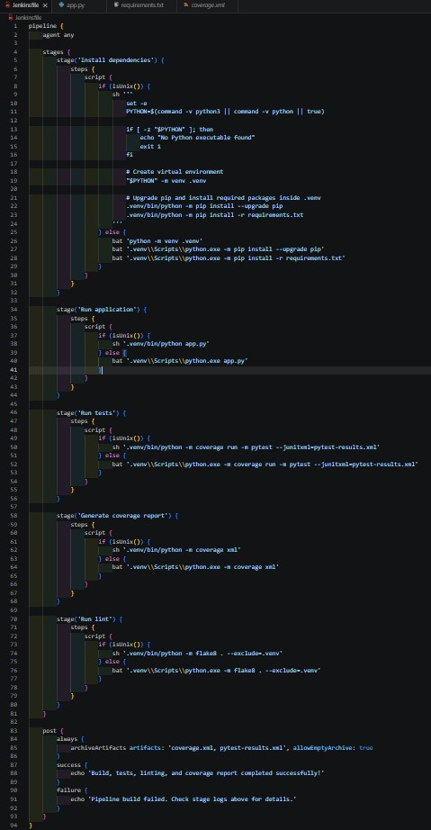

Step 10 Install Jenkins Plugins

Step 11 Create Jenkins Pipeline
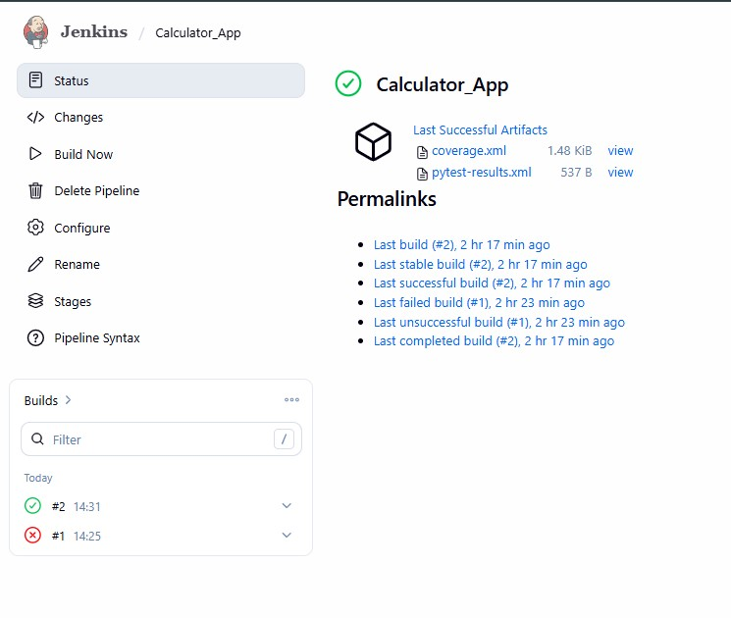

Step 12 Observe Console Output
+ .venv/bin/python app.py
Calculator Application
Addition = 25
Subtraction = 5
Multiplication = 150
Division = 1.5
[Pipeline] }
[Pipeline] // script
[Pipeline] }
[Pipeline] // stage
[Pipeline] stage
[Pipeline] { (Run tests)
[Pipeline] script [Pipeline] {
[Pipeline] isUnix
[Pipeline] sh
+ .venv/bin/python -m coverage run -m pytest --junitxml=pytest-results.xml ============================= test session starts ============================== platform linux -- Python 3.13.5, pytest-9.1.1, pluggy-1.6.0 rootdir: /var/jenkins_home/workspace/Calculator_App collected 4 items

test_calculator.py .... [100%] - generated xml file: /var/jenkins_home/workspace/Calculator_App/pytestresults.xml -
============================== 4 passed in 0.04s ===============================
[Pipeline] }
[Pipeline] // script
[Pipeline] }
[Pipeline] // stage
[Pipeline] stage
[Pipeline] { (Generate coverage report)
[Pipeline] script
[Pipeline] {
[Pipeline] isUnix
[Pipeline] sh
+ .venv/bin/python -m coverage xml
Wrote XML report to coverage.xml
[Pipeline] }
[Pipeline] // script
[Pipeline] }
[Pipeline] // stage
[Pipeline] stage
[Pipeline] { (Run lint)
[Pipeline] script [Pipeline] {
[Pipeline] isUnix
[Pipeline] sh
+ .venv/bin/python -m flake8 . --exclude=.venv
[Pipeline] }
[Pipeline] // script
[Pipeline] }
[Pipeline] // stage
[Pipeline] stage
[Pipeline] { (Declarative: Post Actions)
[Pipeline] archiveArtifacts
Archiving artifacts
[Pipeline] echo
Build, tests, linting, and coverage report completed successfully!
[Pipeline] }
[Pipeline] // stage
[Pipeline] }
[Pipeline] // withEnv
[Pipeline] }
[Pipeline] // node
[Pipeline] End of Pipeline
Finished: SUCCESS

